Cairo University  
Faculty of Computers and Information



**CS251**

**Software Engineering II**

E-Library

Software Design

Sara ElSheemi – Hagar Gadallah-Youssef Nabil – Tarek Abdalla-Hana Ahmed

11/2016

Contents

Instructions [To be removed] 3

Team 3

Document Purpose and Audience 3

System Models 3

I. System Decomposition 3

II. Class diagrams 6

Important Algorithm 7

III. Sequence diagrams 8

Class - Sequence Usage Table 9

IV. Physical Entity-Relationship Diagram 10

V. User Interface Design 10

VI. Bonus: State Diagram and OCL 12

Ownership Report 12

Policy Regarding Plagiarism: 12

References 12

Authors 12

# Team

|  |  |  |  |
| --- | --- | --- | --- |
| **ID** | **Name** | **Email** | **Mobile** |
| 20146020 | Sara ElSheemi | Saraelsheemi93@yahoo.com |  |
| 20146014 | Hagar Gadallah | [hagargadallah@gmail.com](mailto:hagargadallah@gmail.com) |  |
| 20146015 | Youssef Nabil | Hana_ahmed@hotmail.com |  |
| 20146010 | Tarek Abdallah | t.abdalla@outlook.com |  |

# Document Purpose and Audience

* **Lists the component of the system through illustrative diagrams.**
* **Intended for TA.**

# System Models

## I. System Decomposition

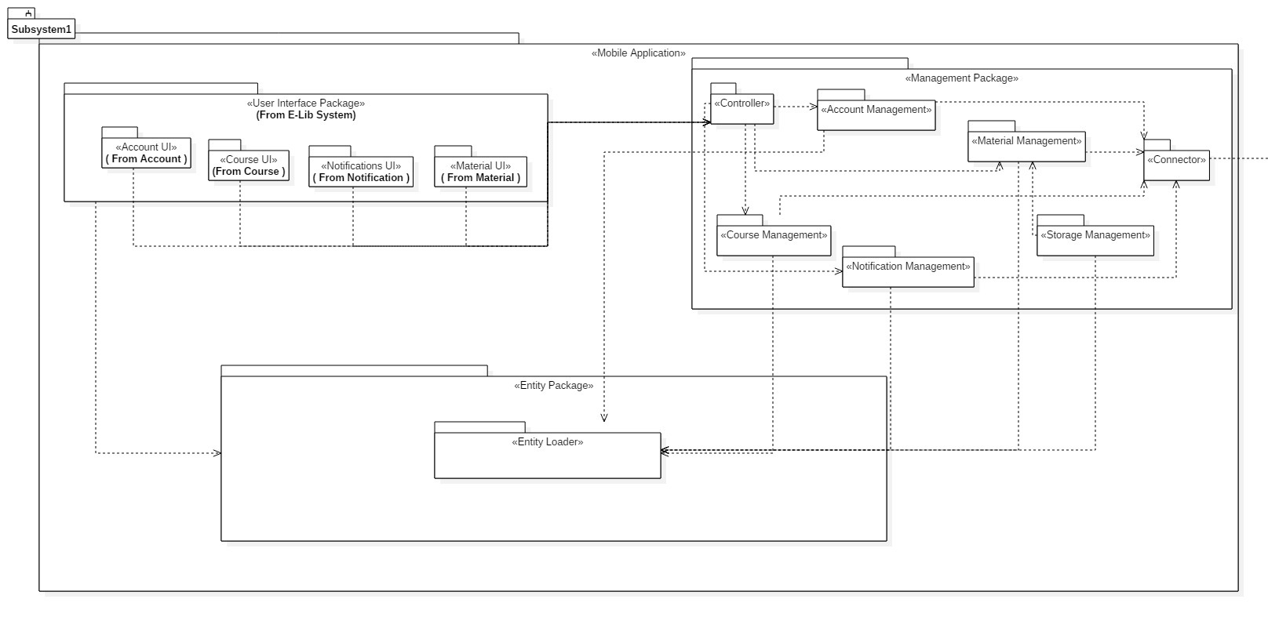

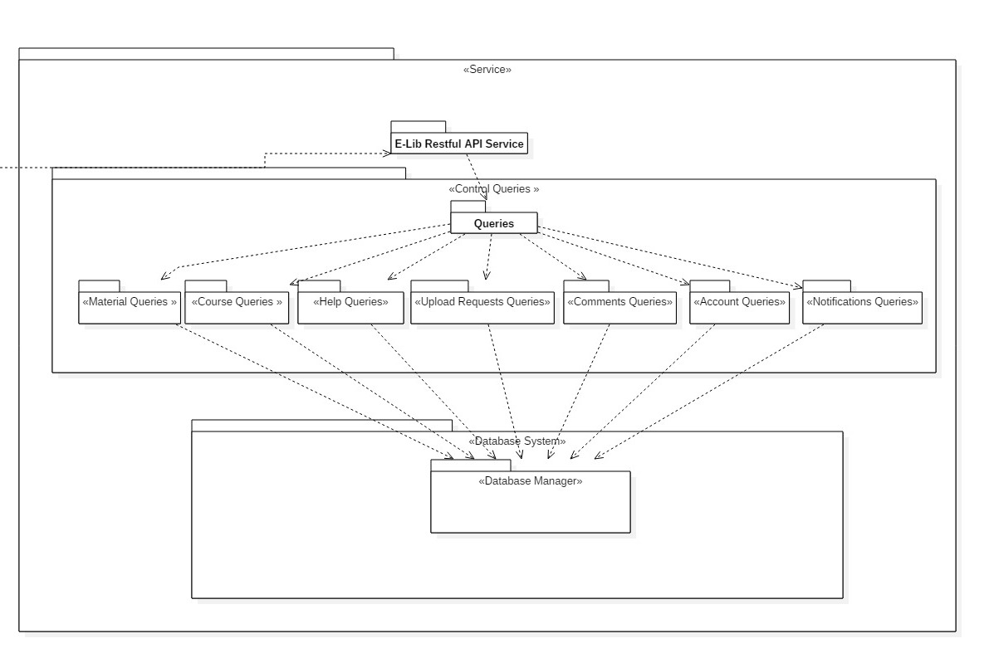

## II. Class diagrams

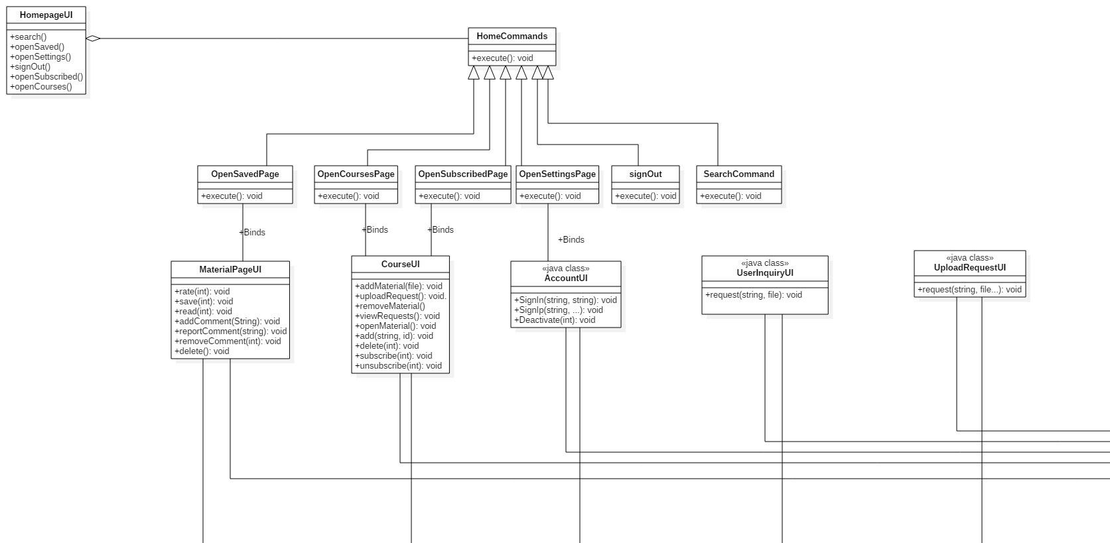

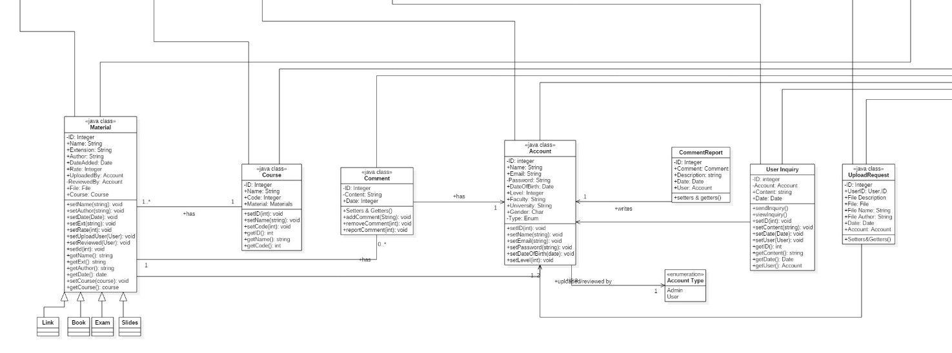

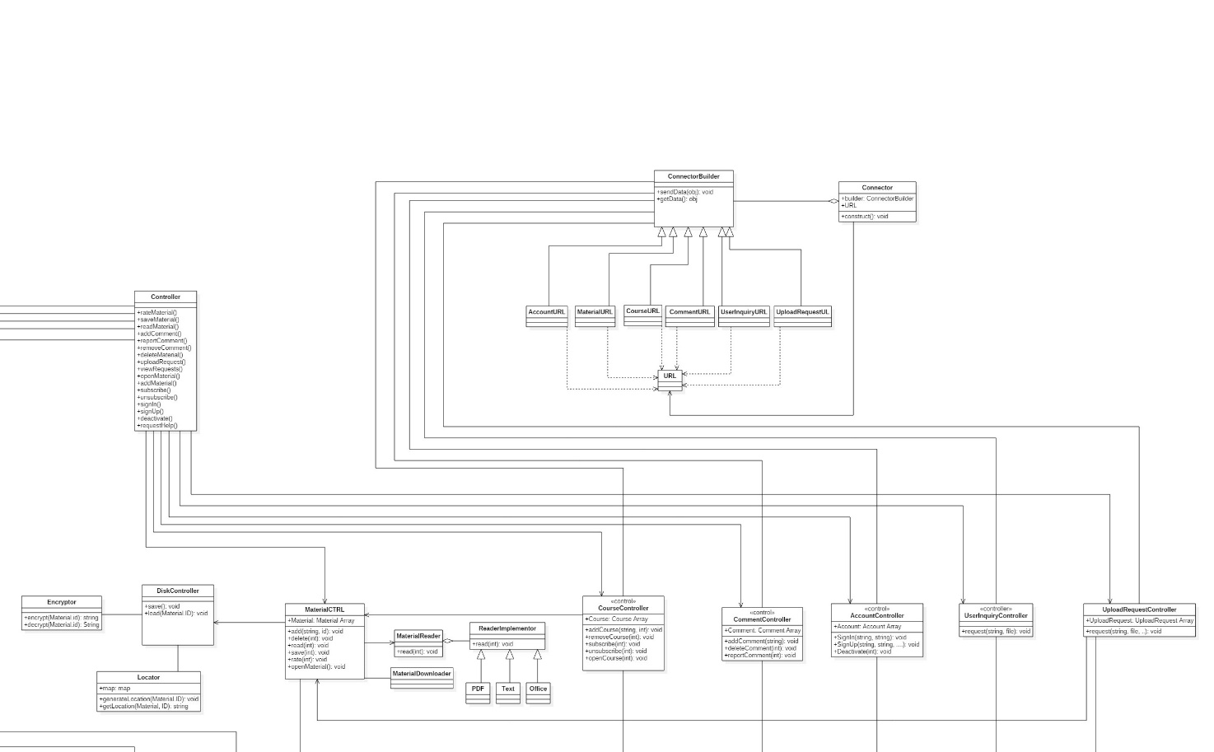

**Server Side**

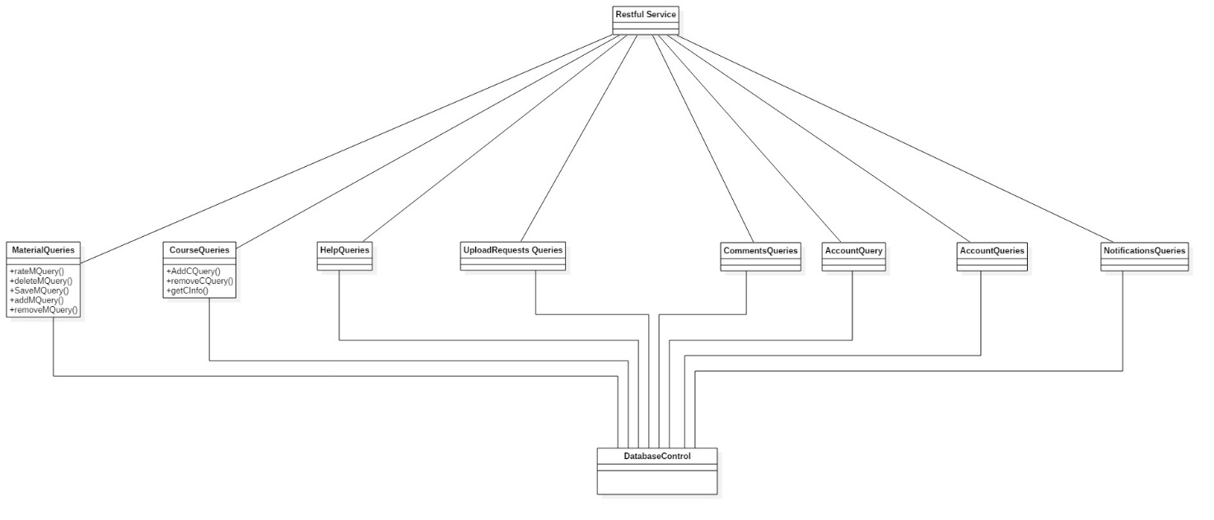

**List down your classes and describe them**

| **Class ID** | **Class Name** | **Subsystem ID** | | **Description & Responsibility** |
| --- | --- | --- | --- | --- |
| 1 | HomePageUI | Account UI | | Directs the user to all the activities on the homepage |
| 2 | HomeCommand | Account CTRL | | General command pattern for all the commands on the homepage |
| 3 | SavedPage | Material UI | | Opens saved pages |
| 4 | CoursesPage | Course UI | | Opens courses pages |
| 5 | SubscribedPage | Course UI | | Open subscribes pages |
| 6 | SettingsPage | Account UI | | Opens settings |
| 7 | SignOut | Account UI | | Sign outs from account |
| 8 | Search | Account CTRL | | Opens search page |
| 9 | MaterialUI | Material UI | | Creates material CTRL object |
| 10 | CourseUI | Course UI | | Creates course CTRL object |
| 11 | AccountUI | Account UI | | Creates account CTRL object |
| 12 | UserInquiryUI | Account UI | | Creates user inquiry CTRL object |
| 13 | UploadRequestUI | Material UI | | Creates upload request CTRL object |
| 14 | Controller | Controller | | Takes all operations from UI layer and forward to appropriate CTRL class |
| 15 | MaterialController | Material CTRL | | Contains all operations related to material |
| 16 | CourseController | Course CTRL | | All operations done on courses |
| 17 | CommentController | Material CTRL | | All operations done on comments |
| 18 | AccountController | Account CTRL | | All operations done on an account |
| 19 | UserInquiryController | AccountCTRL | | Requesting user inquiry |
| 21 | UploadRequestController | MaterialCTRL | Sending an upload request | | |
| 22 | Material | Entity Loader | | All information related to material |
| 23 | Account | Entity Loader | | All information related to an account |
| 24 | Comment | Entity Loader | | All information related to comments |
| 25 | Course | Entity Loader | | All information related to courses |
| 26 | Comment Report | Entity Loader | | All information related to comment reports |
| 27 | User Inquiry | Entity Loader | | All information related to user inquires |
| 28 | Upload Request | Entity Loader | | All information related to upload requests |
| 29 | Account Type | Entity Loader | | Enumeration |
| 30 | Disk Loader | MaterialCTRL | | Loads material from physical memory |
| 31 | Encryptor | MaterialCTRL | | Encrypts material’s name and extension |
| 32 | Locator | MaterialCTRL | | Generate location from material |
| 33 | Material Reader | MaterialCTRL | | Director of the reader implementor |
| 34 | Connector Builder | Controller | | Takes controller from all controller classes and generates appropriate URL |
| 35 | Reader Implementor | MaterialCTRL | | Builder to opens different extensions of material |
| 36 | Material Downaloder | MaterialCTRL | | Gets material from server |
| 37 | Account URL | AccountCTRL | | url with an account related request |
| 38 | MaterialURL | MaterialCTRL | | url with a material related request |
| 39 | CourseURL | CourseCTRL | | url with a course related request |
| 40 | CommentURL | MaterialCTRL | | url with a comment related request |
| 41 | UserInquiryURL | AccoutCTRL | | url with a uaer inquiry related request |
| 42 | UploadRequestURL | MaterialCTRL | | url with upload request related request |
| 43 | Connector | Controller | | Takes url requests and sends them to appropriate queries class in the backend and the other way around. |
| 44 | Account Queries | Account Queries | | Performs all operations related to accounts to the database |
| 45 | Course Queries | Course Queries | | Performs all operations related to courses to the database |
| 46 | Help Queries | Help Queries | | Performs all operations related to help to the database |
| 47 | Upload request queries | Upload request queries | | Performs all operations related to upload requests to the database |
| 48 | Comment queries | Comment queries | | Performs all operations related to comments to the database |
| 49 | Notification queries | Notification queries | | Performs all operations related to notifications to the database |
| 50 | Database | Database Manager | | Stores all information related to system |

### Important Algorithm

* **If any method in a class is implementing an algorithm (complex enough), then you should describe it here.**

## 

## III. Sequence diagrams

**1 )Sign Up:**

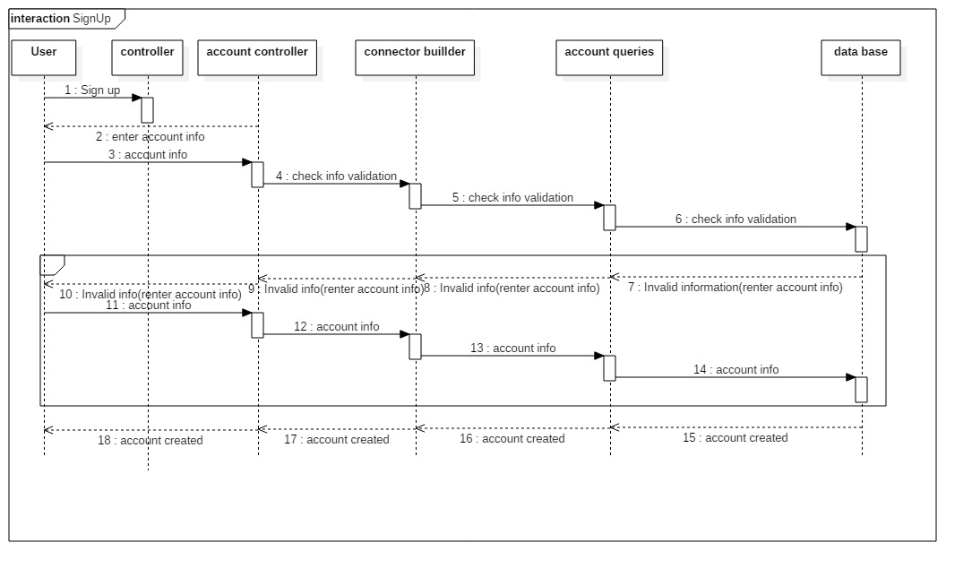

**2)Log Out:** 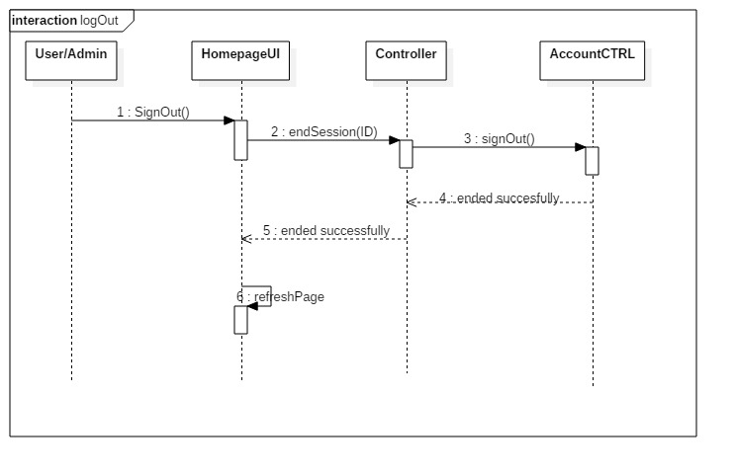

**3)Add Material:**

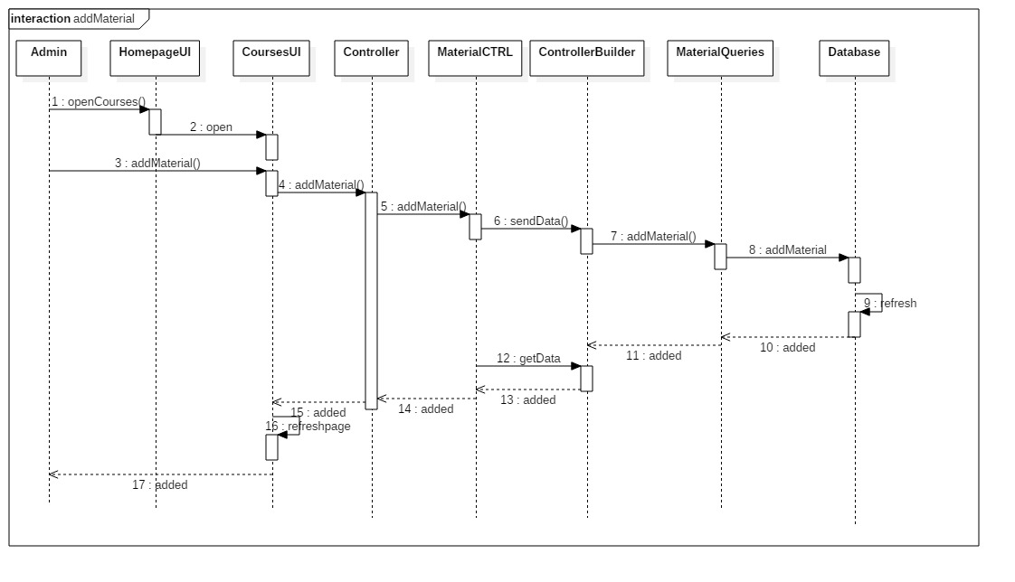

**4)Save Material:**

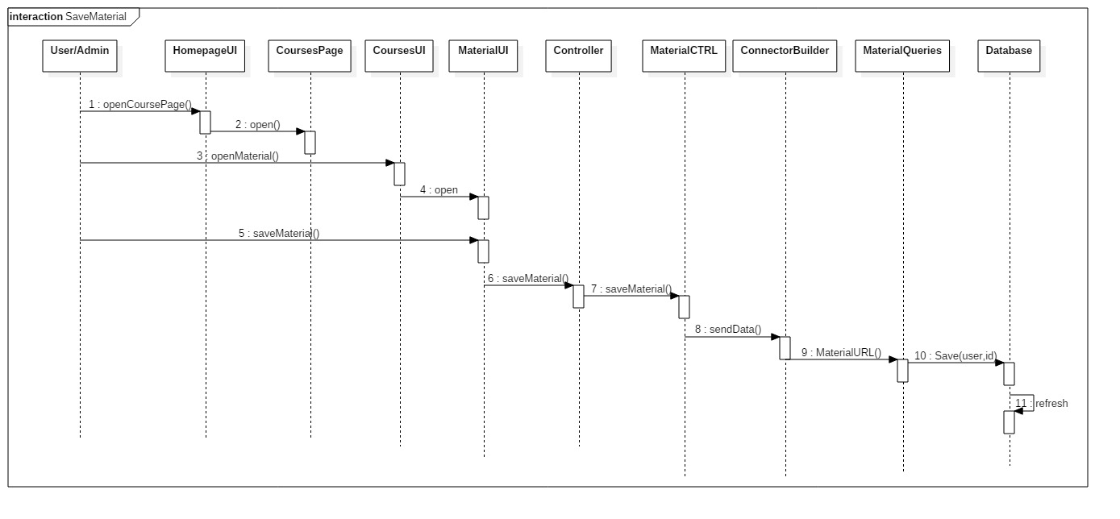

**5)Create Course:**

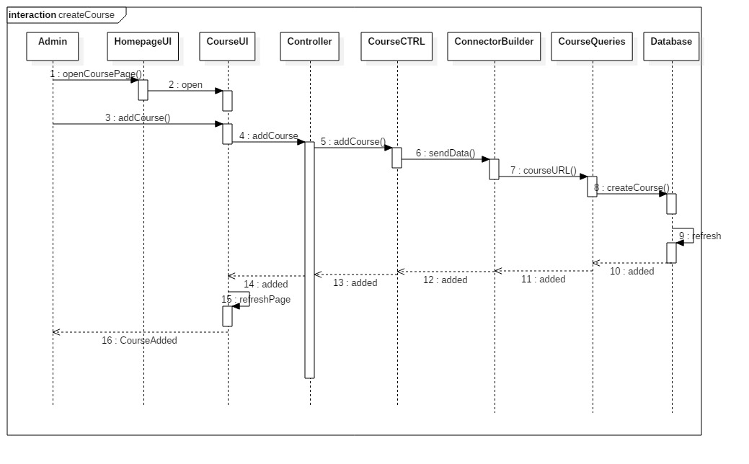

**6)Delete Course:**

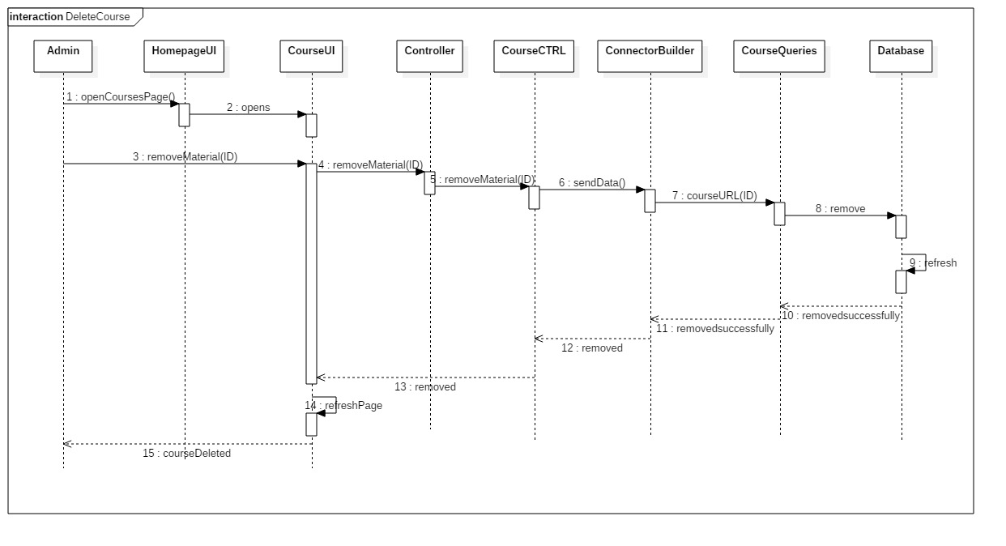

**7)Report Comment:**

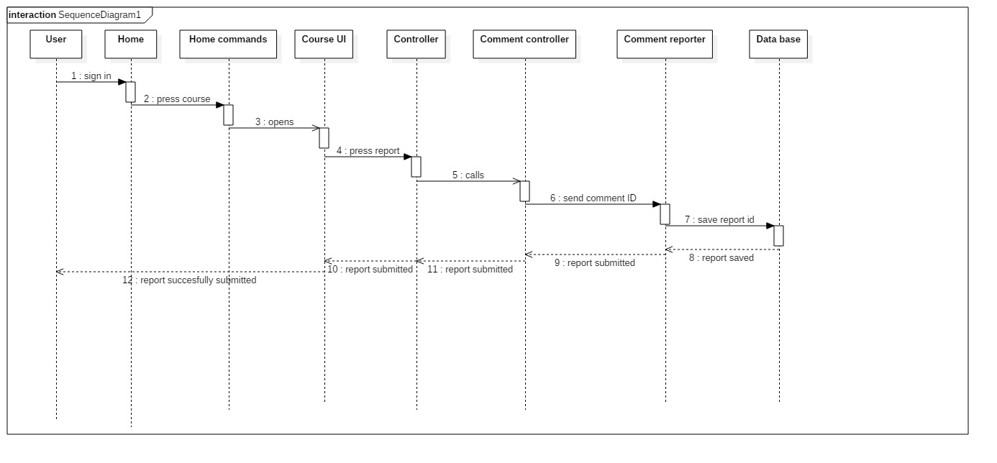

**8) Search:** 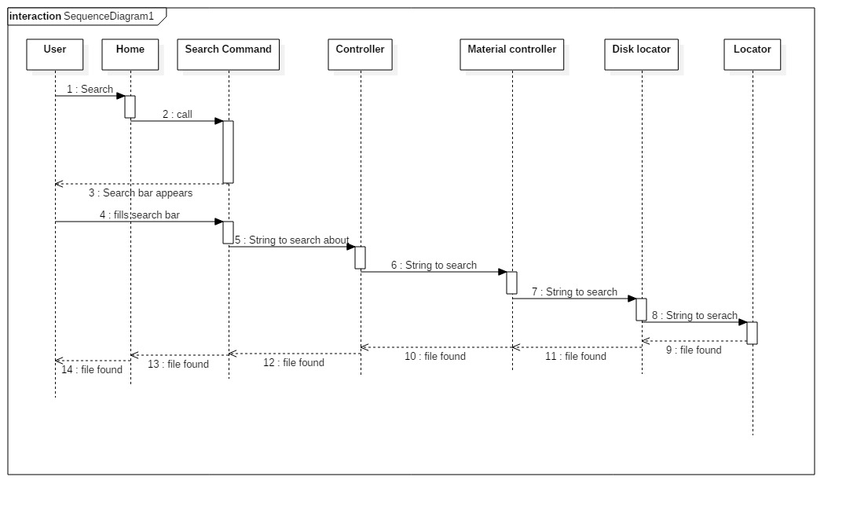

9**) Upload Request**:

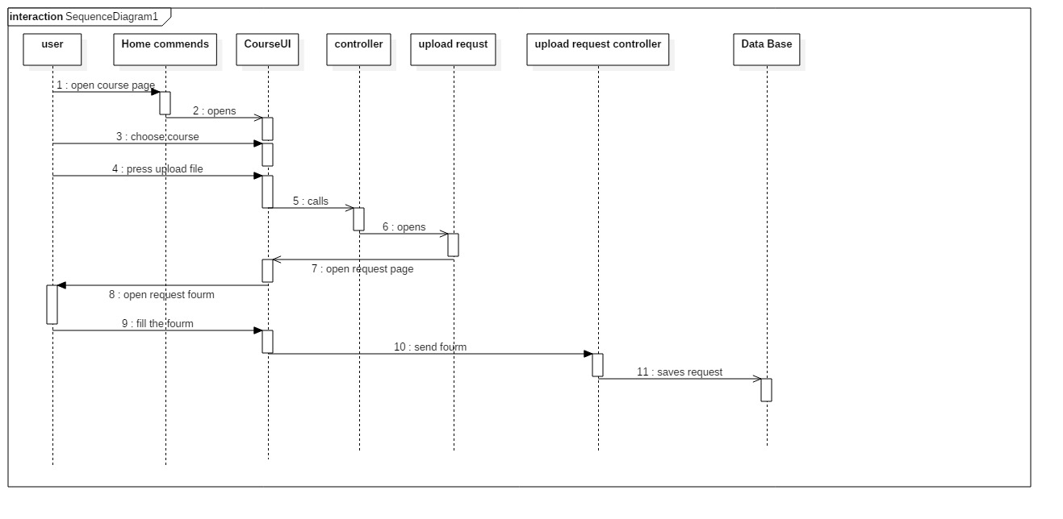

### 10) Review Request:

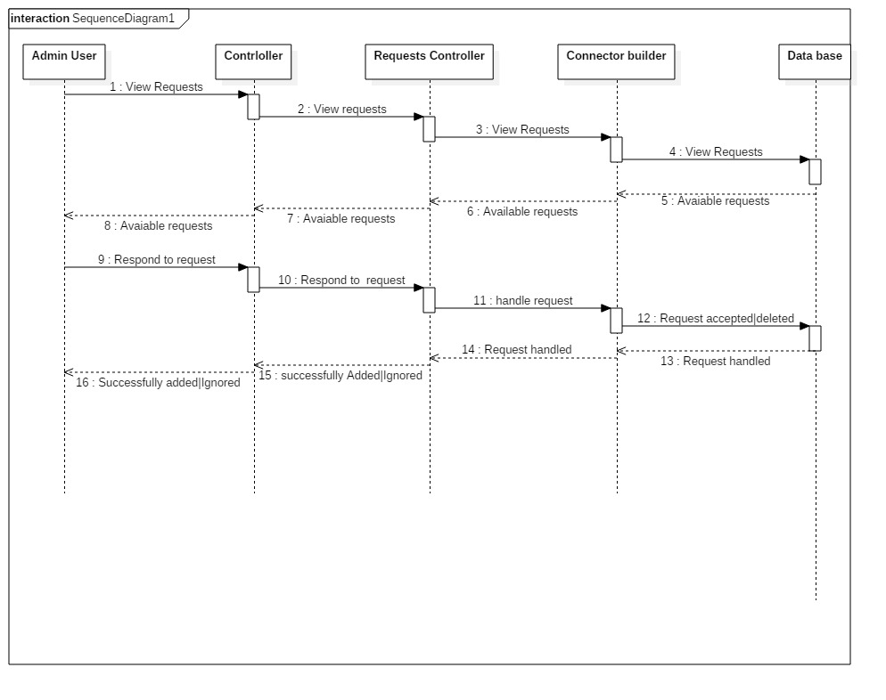

**11)Subscribe:**

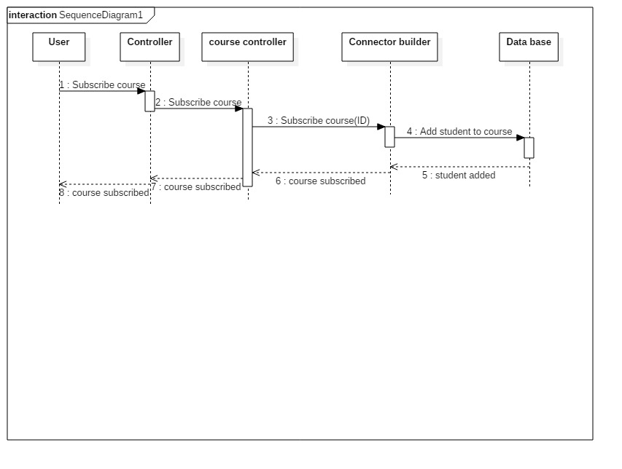

**12)Add Amin**

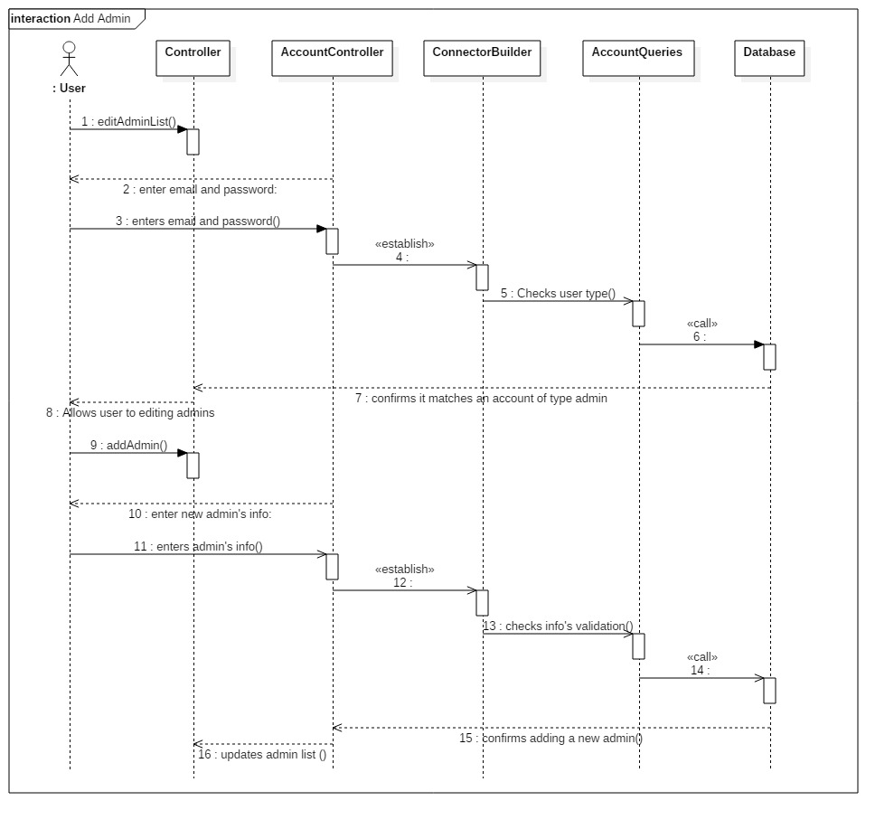

**13) Remove Admin**

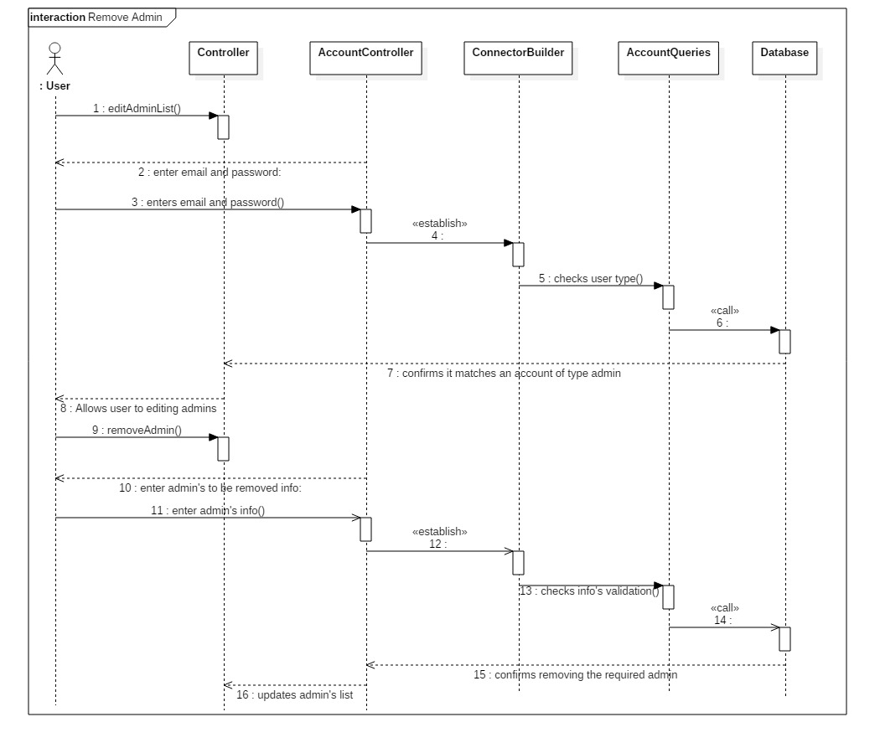

**14 ) Add Comment**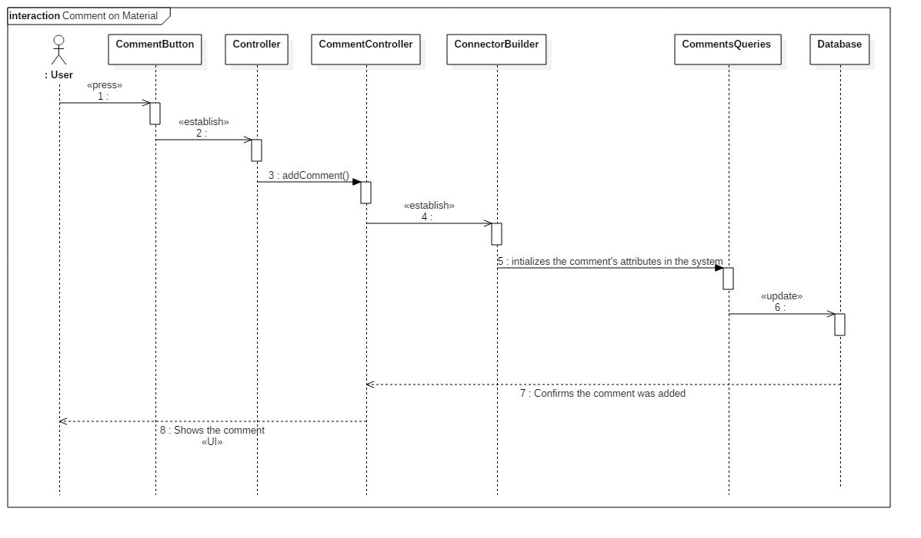

**15) Sign In** 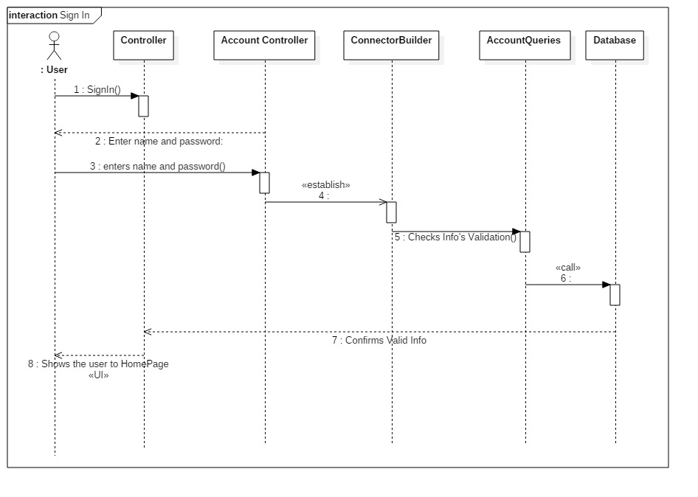

**16) Send Inquiry**

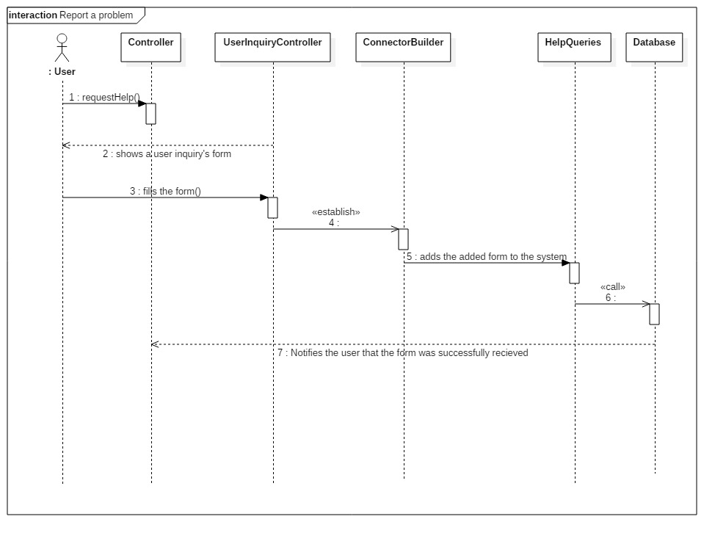

**17) Delete Material**

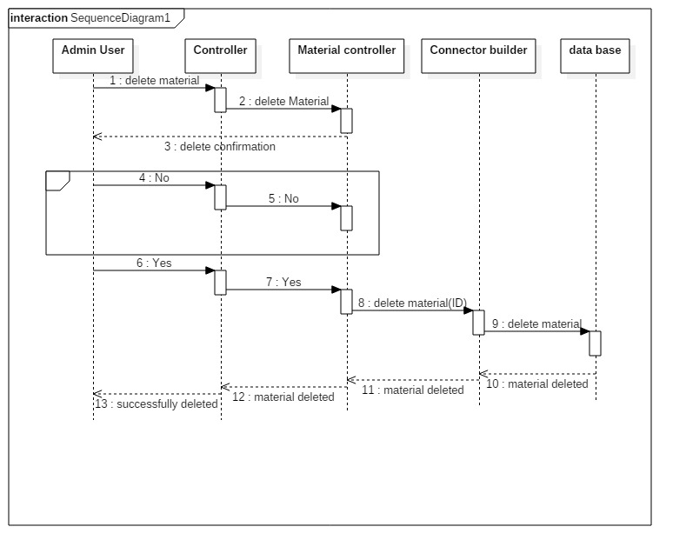

**18) Edit Material**

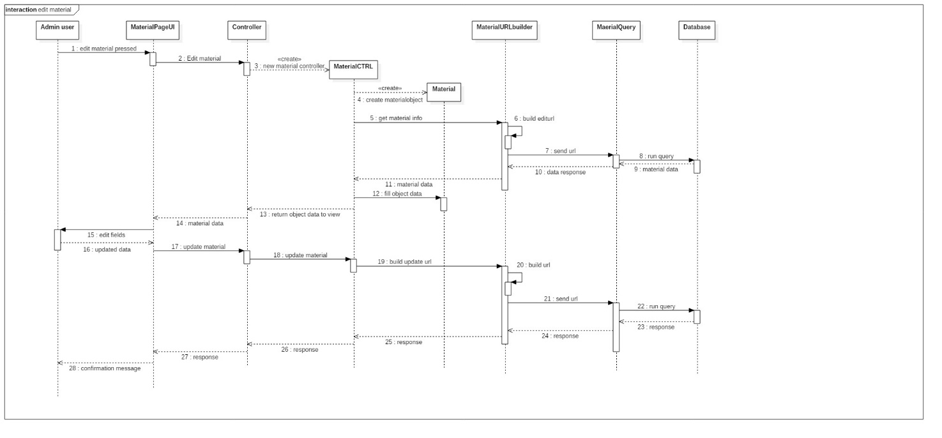

**19) Rate Material:**

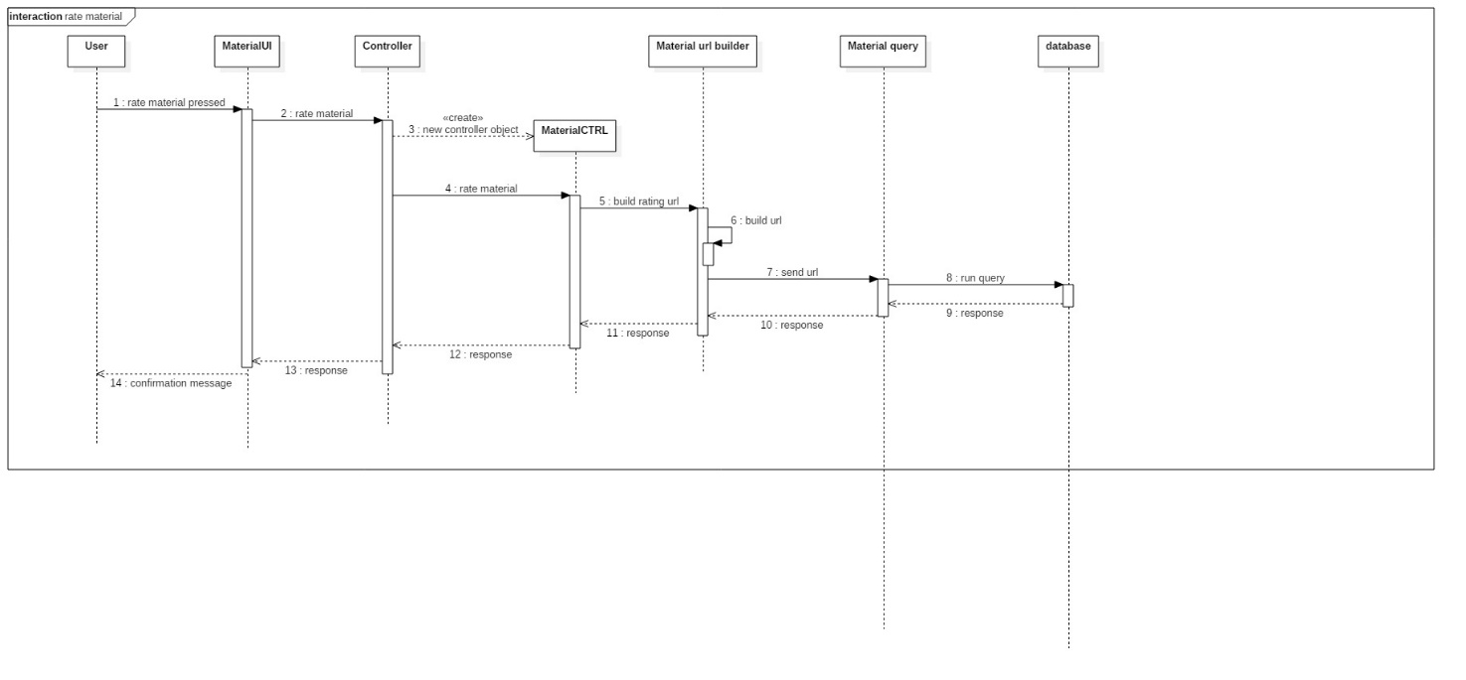

**20) Update Profile** 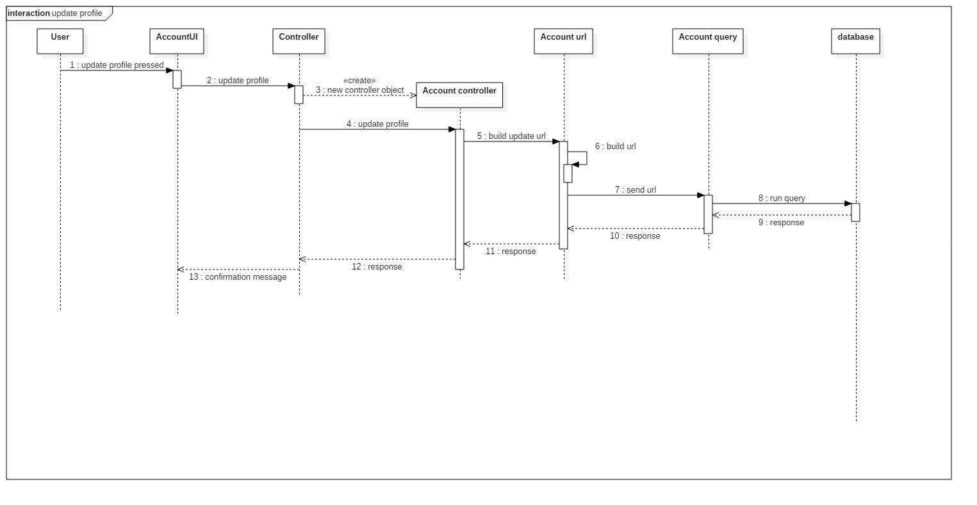

### 21) Read Material

### 

### Class - Sequence Usage Table

| **Class Name** | **Sequence Diagrams** | **Overall used methods** |
| --- | --- | --- |
| E.g. Employee | 1, 3, 5 (means Seq Ids 1, 3, 5 used Employee class) | Save, GetData |
|  |  |  |

## IV. Physical Entity-Relationship Diagram

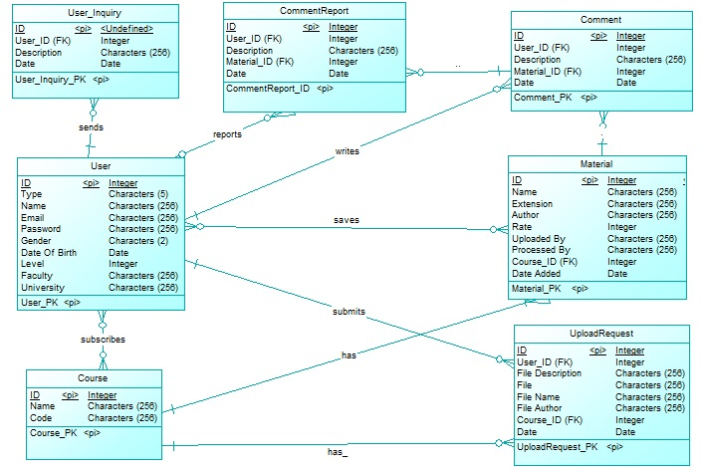

## 

## V. User Interface Design

* **Screen 1 – Login Screen**

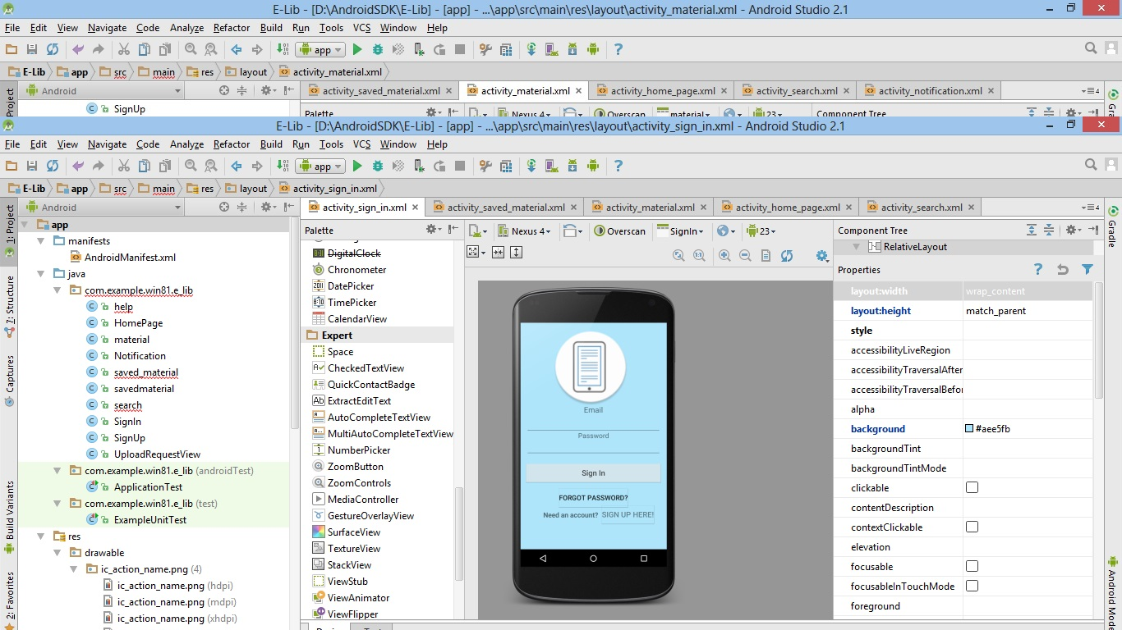

* **Screen 2 – Home Page**

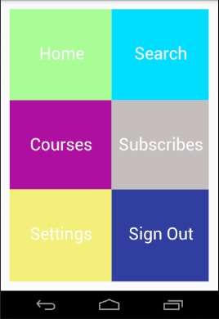

* **Navigation tree: Login Screen**

**|**

* **Navigation tree: HomePage**

**Screen 3 – Sign up**

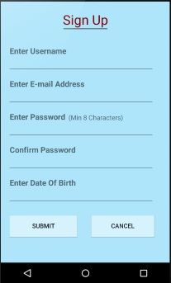

* **Navigation tree: Login Screen**

**|**

* **Navigation tree: SignUp**

**Screen 4 – Notification Page**

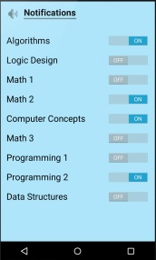

* **Navigation tree: Login Screen**

**|**

* **Navigation tree: HomePage**

**|**

* **Navigation tree: Settings**

**|**

* **Navigation tree: Notification Settings**

**Screen 5 – Material Page**

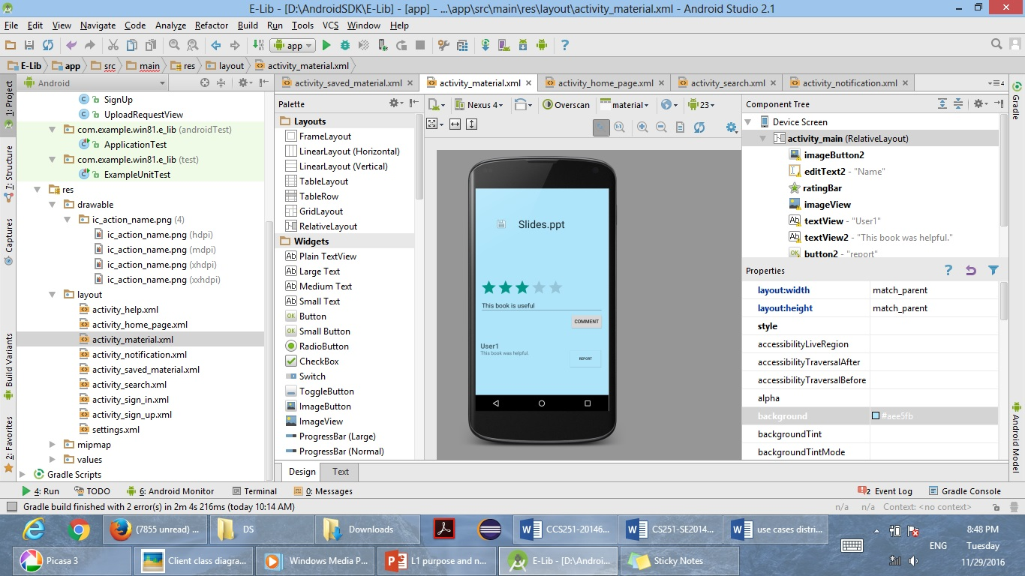

* **Navigation tree: 1) Login Screen**

**|**

* **Navigation tree: HomePage**

**|**

* **Navigation tree: Courses**

**|**

* **Navigation tree: Material**
* **2) Login Screen**

**|**

* **Navigation tree: HomePage**

**|**

* **Navigation tree: Saved**

**|**

* **Navigation tree: Material**

**Screen 6 – View Requests List**

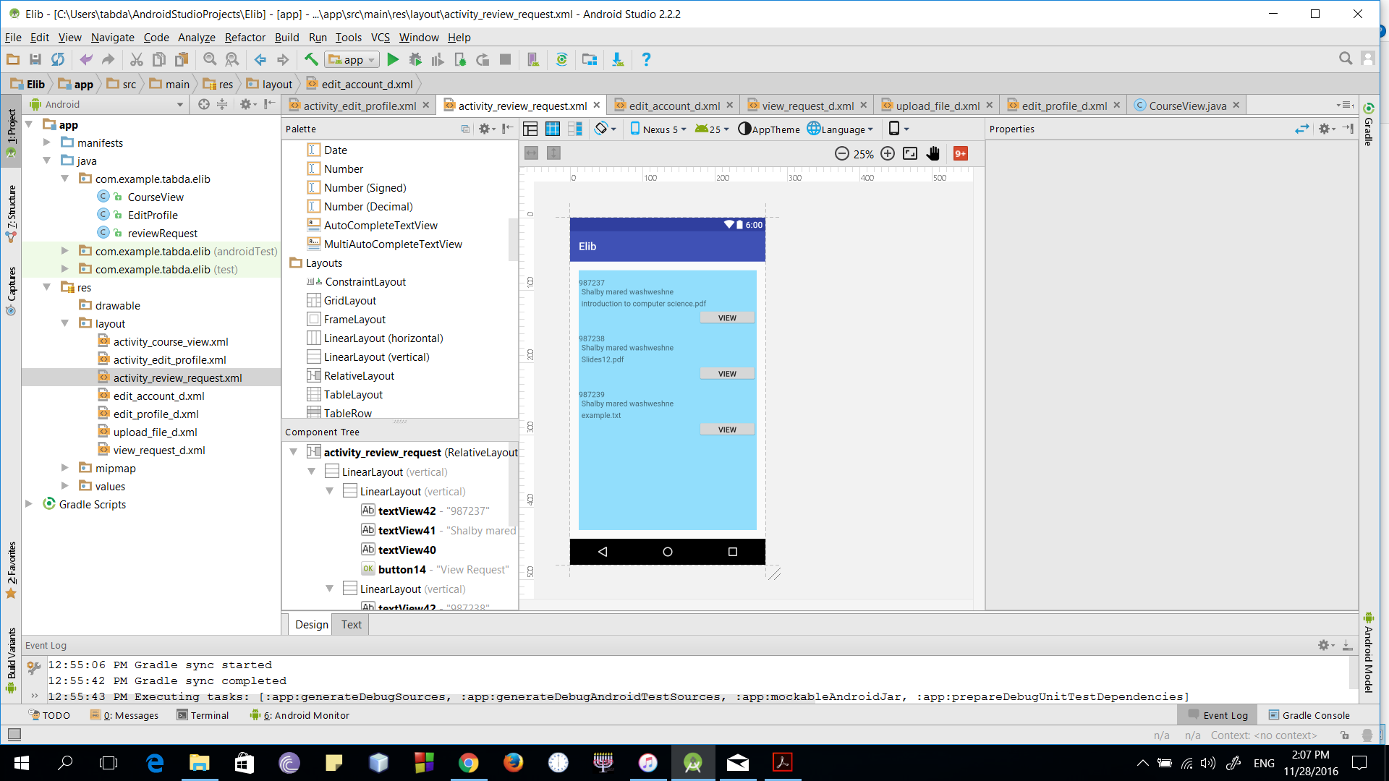

* **Navigation tree: Login Screen**

**|**

* **Navigation tree: HomePage**

**|**

* **Navigation tree: Courses**

**|**

* **Navigation tree: View Requests List**

**Screen 6 – View Request**

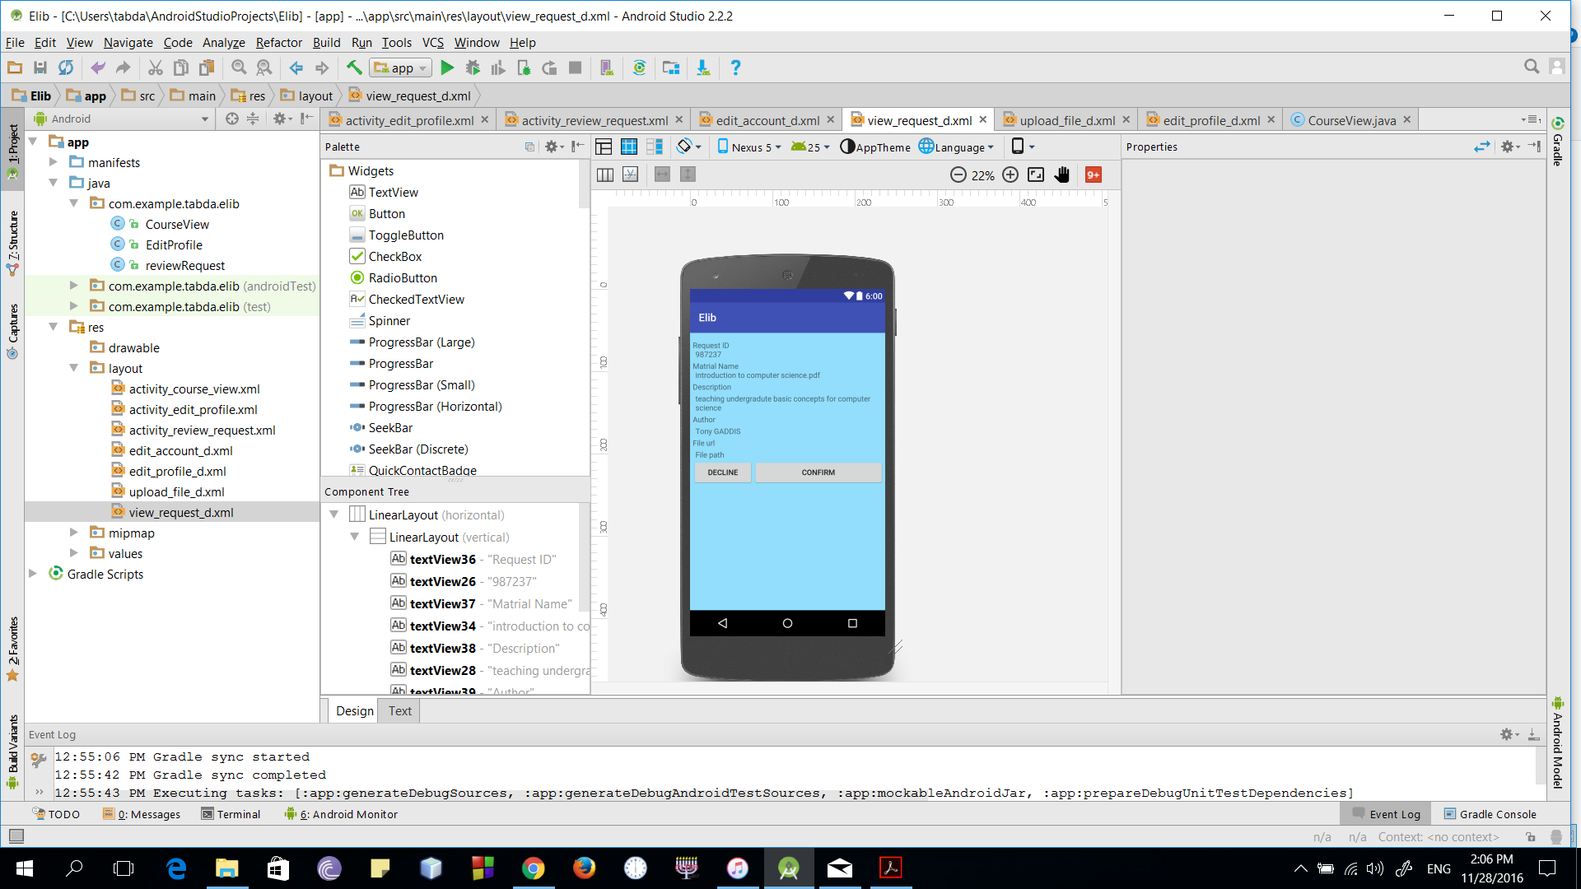

* **Navigation tree: Login Screen**

**|**

* **Navigation tree: HomePage**

**|**

* **Navigation tree: Courses**

**|**

* **Navigation tree: View Requests List**

**|**

* **Navigation tree: View Request**

**Screen 8 – Upload Request**

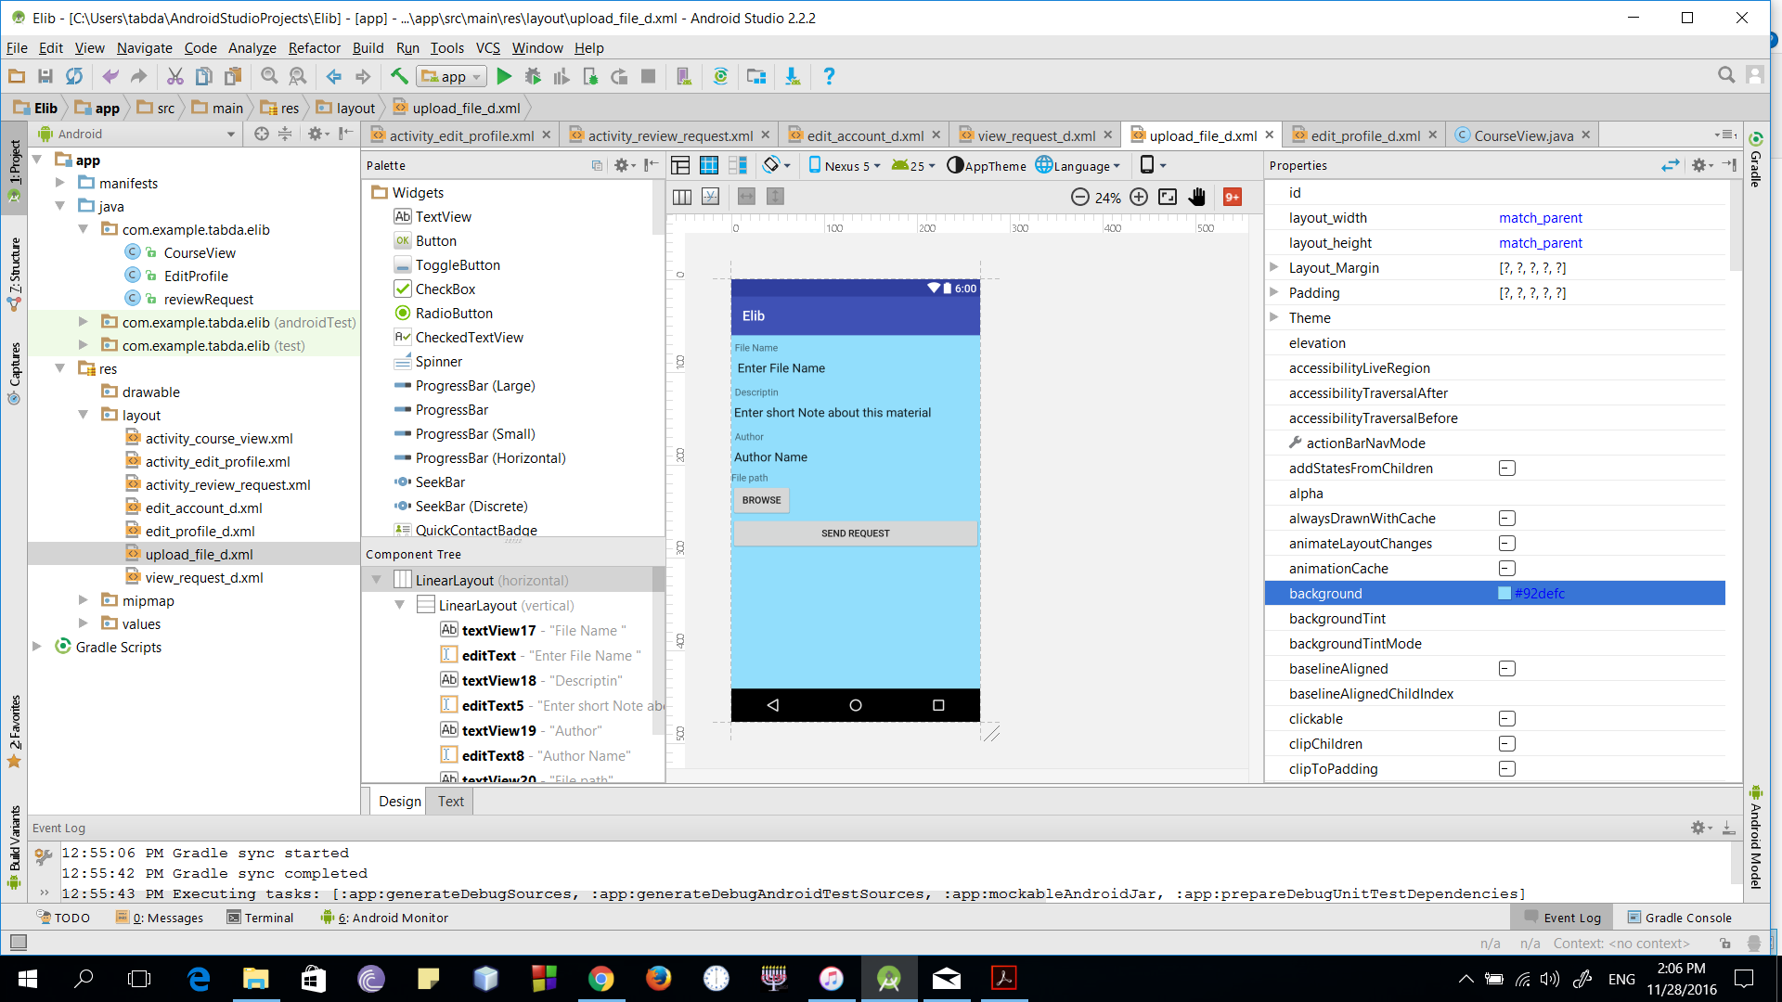

* **Navigation tree: Login Screen**

**|**

* **Navigation tree: HomePage**

**|**

* **Navigation tree: Courses**

**|**

* **Navigation tree: Upload Request**

**Screen 9 – Edit Profile**

* 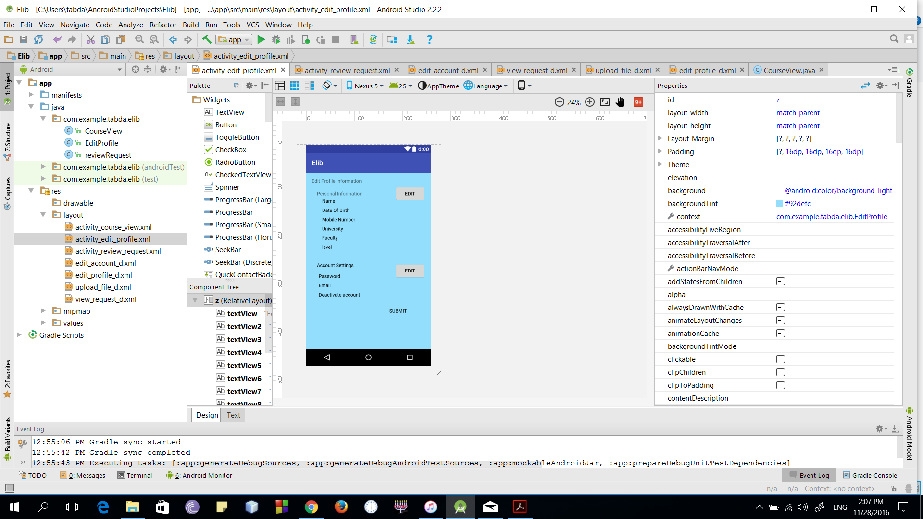
* **Navigation tree: Login Screen**

**|**

* **Navigation tree: HomePage**

**|**

* **Navigation tree: Settings**

**|**

* **Navigation tree: Edit Profile**

**Screen 10 – Edit Personal Information**

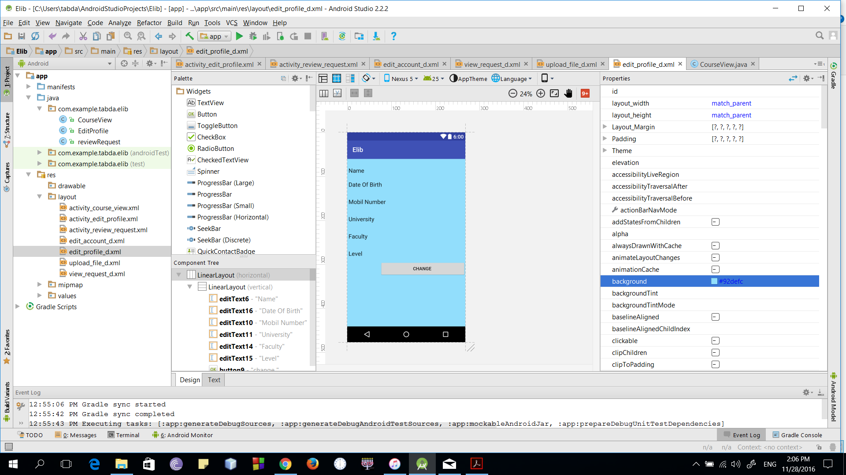

* **Navigation tree: Login Screen**

**|**

* **Navigation tree: HomePage**

**|**

* **Navigation tree: Settings**

**|**

* **Navigation tree: Edit Profile**

**|**

* **Navigation tree: Edit Personal Information**

**Screen 11 – Edit Account Information**

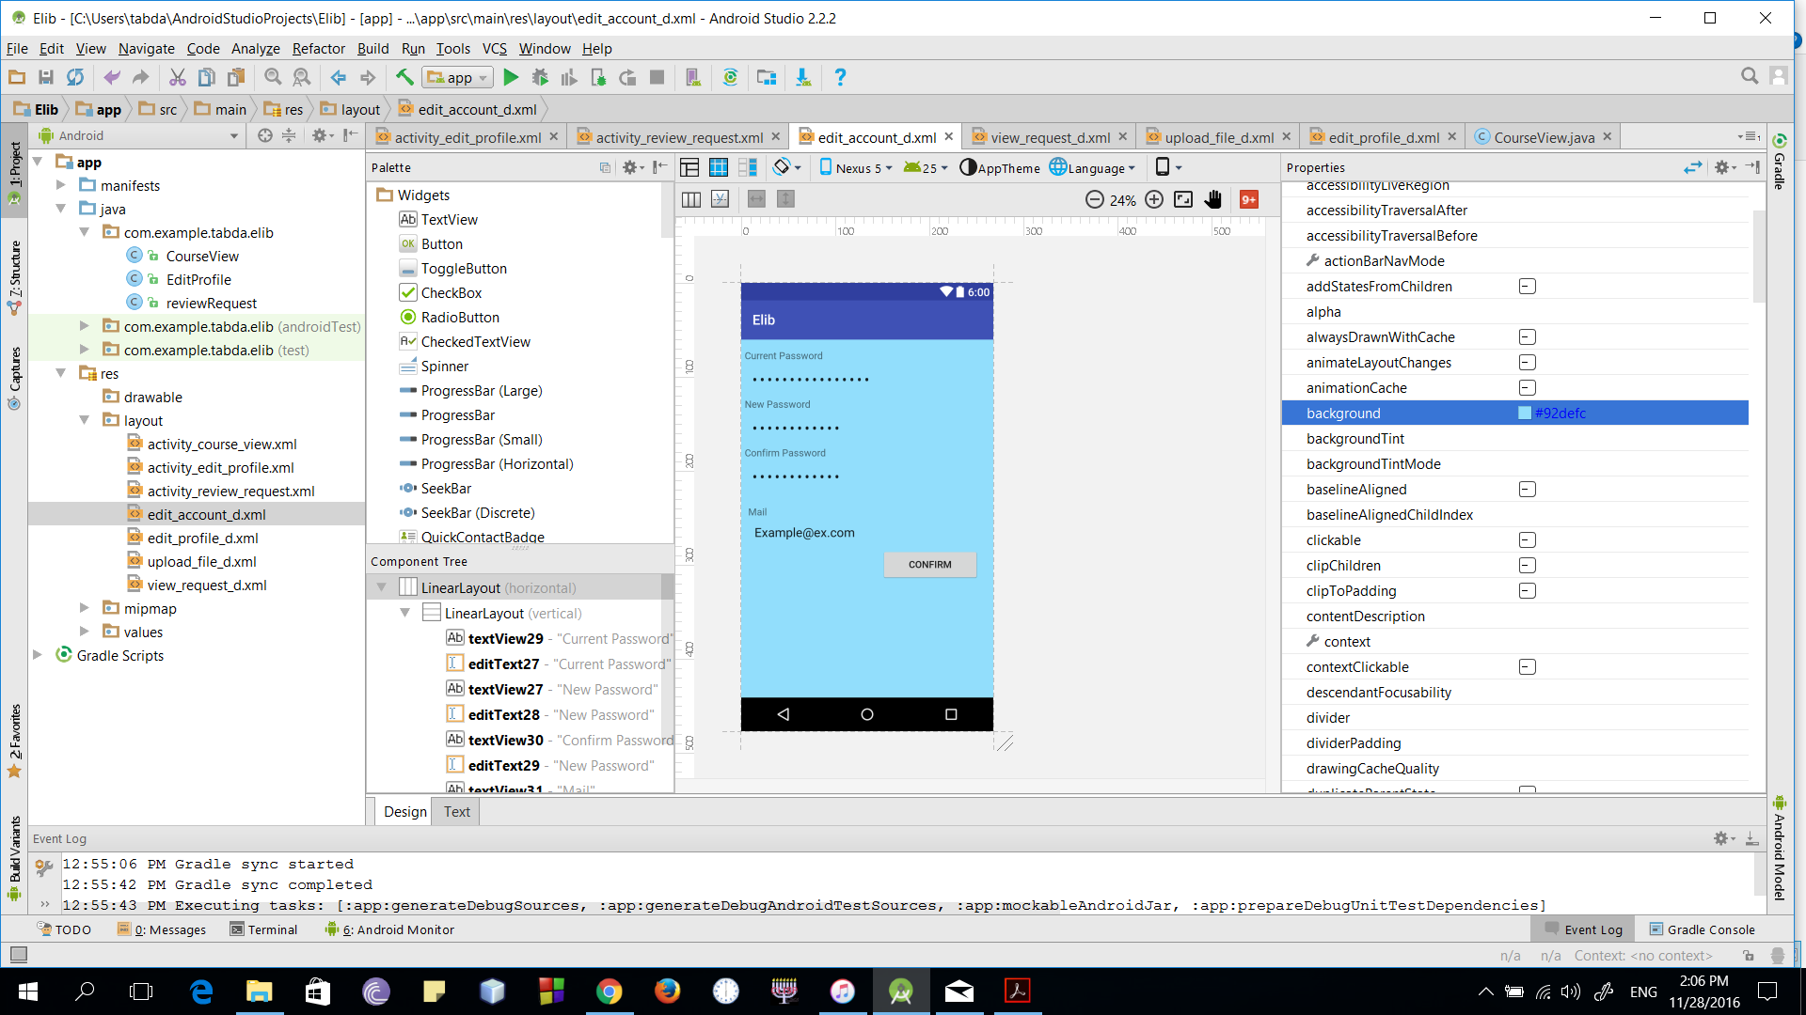

* **Navigation tree: Login Screen**

**|**

* **Navigation tree: HomePage**

**|**

* **Navigation tree: Settings**

**|**

* **Navigation tree: Edit Profile**

**|**

* **Navigation tree: Edit Account Information**

**Screen 12 – Course Page**

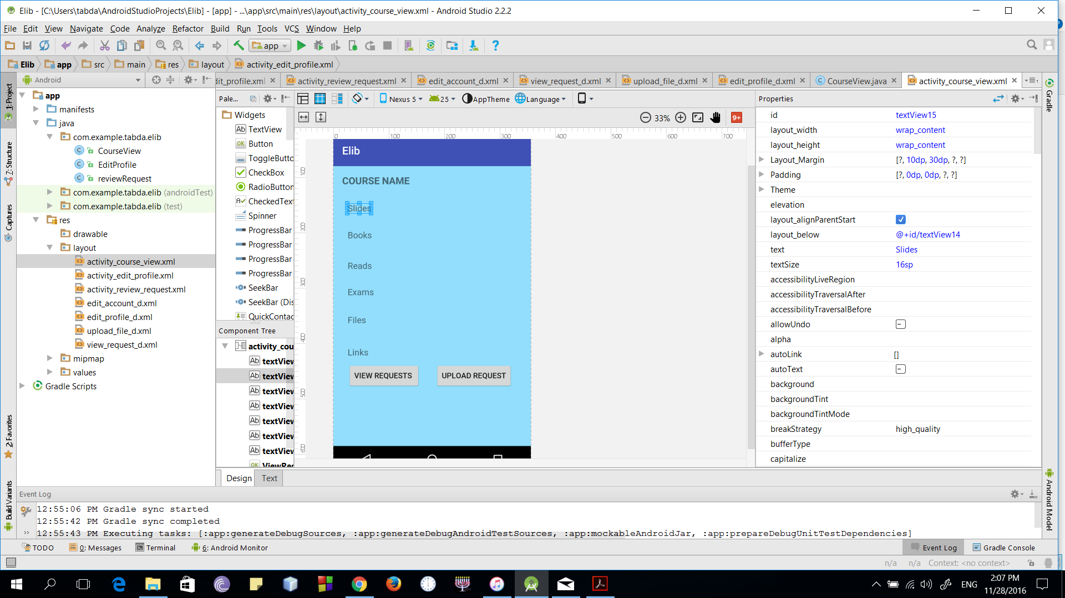

* **Navigation tree: Login Screen**

**|**

* **Navigation tree: HomePage**

**|**

* **Navigation tree: Courses**

**|**

* **Navigation tree: View Course**

**Screen 13 – Saved Material**

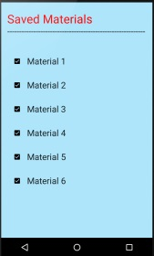

* **Navigation tree: Login Screen**

**|**

* **Navigation tree: HomePage**

**|**

* **Navigation tree: Saved**

**Screen 14 – Settings**

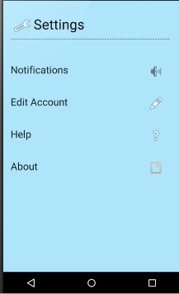**Nn tree:**

* **Navigation tree: Login Screen**

**|**

* **Navigation tree: HomePage**

**|**

* **Navigation tree: Settings**

**Screen 15 – Search**

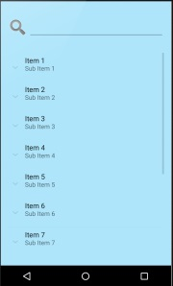

* **Navigation tree: Login Screen**

**|**

* **Navigation tree: HomePage**

**|**

* **Navigation tree: Search**

**Screen 16 – Help**

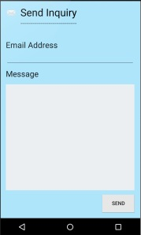

* **Navigation tree: Login Screen**

**|**

* **Navigation tree: Settings**

**|**

* **Navigation tree: Help**

## VI. Bonus: State Diagram and OCL

* **Choose a non-trivial entity that has different states and develop a state diagram for it.**
* **Choose 5 functional requirements that cannot be represented by class and sequence diagrams and develop OCL constraints for them.**

# Ownership Report

|  |  |
| --- | --- |
| **Item** | **Owners** |
|  |  |
|  |  |

# References

* http://www.mhhe.com/engcs/compsci/pressman/graphics/Pressman5sepa/common/cs1/design.pdf

# Authors

* Mostafa Saad and Mohammad El-Ramly